Design feedback

# Colour schemes

Paste your colour schemes on one page here

1. 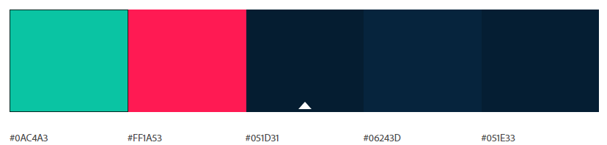

2. 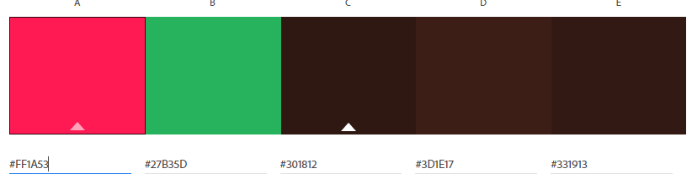

3. 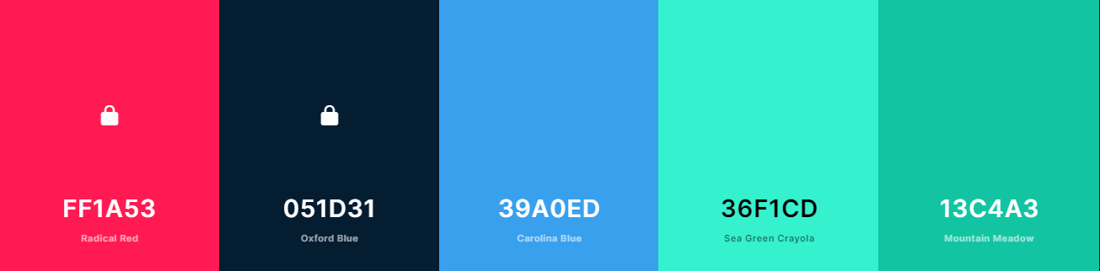

# Font pairs

Paste your font schemes on one page here

1. 



2.





3.





## Mock-up #1

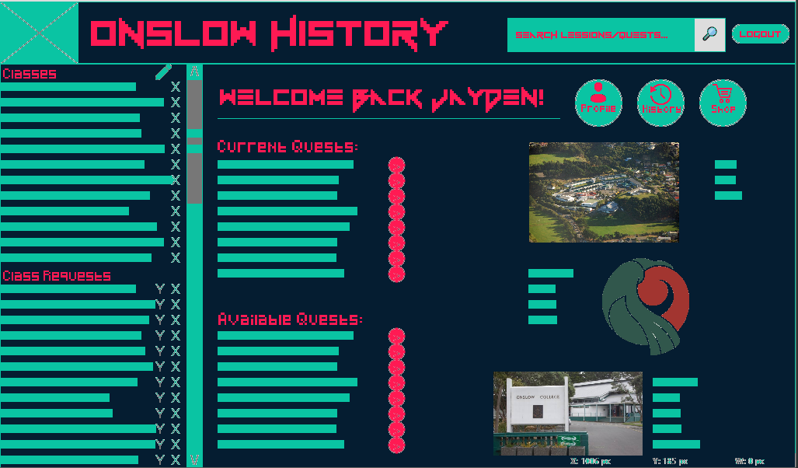

1. Circle/highlight the words that come to mind when you look at the **colour** scheme.

|  |  |  |  |  |  |
| --- | --- | --- | --- | --- | --- |
| Professional | Warm | Childish | Simple | Shambolic | Relaxed |
| Overbearing | Casual | Engaging | Clever | Serious | Cold |
| Sloppy | Trustworthy | Playful | Interesting | Easy | Arrogant |
| Inclusive | Sleek | Detailed | Confident | Chilled | Clinical |
| Authoritative | Exciting | Open | Laid back | Fun | Amateur |
| Supportive | Stuffy | Silly | Helpful | Enthusiastic | Bossy |

1. Circle/highlight the words that come to mind when you look at the **font** scheme.

|  |  |  |  |  |  |
| --- | --- | --- | --- | --- | --- |
| Professional | Warm | Childish | Simple | Shambolic | Relaxed |
| Overbearing | Casual | Engaging | Clever | Serious | Cold |
| Sloppy | Trustworthy | Playful | Interesting | Easy | Arrogant |
| Inclusive | Sleek | Detailed | Confident | Chilled | Clinical |
| Authoritative | Exciting | Open | Laid back | Fun | Amateur |
| Supportive | Stuffy | Silly | Helpful | Enthusiastic | Bossy |

1. Are there any other words that you associate with this mock-up?

|  |
| --- |
| Mint, cool, Cyberpunk, |

1. What do you think about the choice of:

|  |  |
| --- | --- |
| Background colour | Background colour is great |
| Text colour(s) | Text colours are really good |
| Text-on-background combination | Text on background works really well as the text stands out from the darker bg colour. |
| Accent colour(s) | Bright pink accent colours are really effective |

1. Circle/highlight any statements you find applicable:

|  |  |  |
| --- | --- | --- |
| The **colours** in the mock-up make text hard to read | The **colours** in the mock-up make it hard to see where I need to interact (click, tap, type, etc.) | The **colours** in the mock-up make it hard to distinguish different sections |
| The **fonts** (including typeface, size, spacing, etc.) in the mock-up make text hard to read | The **fonts** (including typeface, size, spacing, etc.) in the mock-up make it hard to see where I need to interact (click, tap, type, etc.) | The **fonts** (including typeface, size, spacing, etc.) in the mock-up make it hard to distinguish different sections |
| I have not found anything in the mock-up that makes text hard to read | I have not found anything in the mock-up that makes it hard to see where I need to interact | I have not found anything in the mock-up that makes it hard to distinguish different sections |

1. What are the pros about this mock-up?

|  |
| --- |
| Your colours work great together and really give the website a bright exciting appeal   * Profile button |

1. What do you think could be improved about this mock-up?

|  |
| --- |
| One thing that could be improved is lowering the amount of blocks of text as I think it overpowers the website. Less is more   * Links? |

1. Do you have any other feedback?

|  |
| --- |
| I like how you used red and green as accent colours it represents the Onslow colours. |

## Mock-up #2

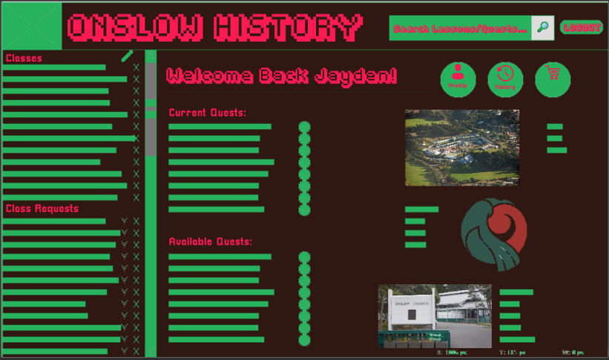

1. Circle/highlight the words that come to mind when you look at the **colour** scheme.

|  |  |  |  |  |  |
| --- | --- | --- | --- | --- | --- |
| Professional | Warm | Childish | Simple | Shambolic | Relaxed |
| Overbearing | Casual | Engaging | Clever | Serious | Cold |
| Sloppy | Trustworthy | Playful | Interesting | Easy | Arrogant |
| Inclusive | Sleek | Detailed | Confident | Chilled | Clinical |
| Authoritative | Exciting | Open | Laid back | Fun | Amateur |
| Supportive | Stuffy | Silly | Helpful | Enthusiastic | Bossy |

1. Circle/highlight the words that come to mind when you look at the **font** scheme.

|  |  |  |  |  |  |
| --- | --- | --- | --- | --- | --- |
| Professional | Warm | Childish | Simple | Shambolic | Relaxed |
| Overbearing | Casual | Engaging | Clever | Serious | Cold |
| Sloppy | Trustworthy | Playful | Interesting | Easy | Arrogant |
| Inclusive | Sleek | Detailed | Confident | Chilled | Clinical |
| Authoritative | Exciting | Open | Laid back | Fun | Amateur |
| Supportive | Stuffy | Silly | Helpful | Enthusiastic | Bossy |

1. Are there any other words that you associate with this mock-up?

|  |
| --- |
|  |

1. What do you think about the choice of:

|  |  |
| --- | --- |
| Background colour | I actually liked the brown background. It can be hard to incorporate brown into your website but I think you did a good job and it works quite well as a background colour. |
| Text colour(s) | Text colour give a massive pop to website so well done |
| Text-on-background combination | Text to background colour combination is all good |
| Accent colour(s) | Accent colours are bright and lively |

1. Circle/highlight any statements you find applicable:

|  |  |  |
| --- | --- | --- |
| The **colours** in the mock-up make text hard to read | The **colours** in the mock-up make it hard to see where I need to interact (click, tap, type, etc.) | The **colours** in the mock-up make it hard to distinguish different sections |
| The **fonts** (including typeface, size, spacing, etc.) in the mock-up make text hard to read | The **fonts** (including typeface, size, spacing, etc.) in the mock-up make it hard to see where I need to interact (click, tap, type, etc.) | The **fonts** (including typeface, size, spacing, etc.) in the mock-up make it hard to distinguish different sections |
| I have not found anything in the mock-up that makes text hard to read | I have not found anything in the mock-up that makes it hard to see where I need to interact | I have not found anything in the mock-up that makes it hard to distinguish different sections |

1. What are the pros about this mock-up?

|  |
| --- |
| [Type here] |

1. What do you think could be improved about this mock-up?

|  |
| --- |
| Again, just less links and words as I think this will make the user feel less overwhelmed by the website. |

1. Do you have any other feedback?

|  |
| --- |
| [Type here] |

## Mock-up #3

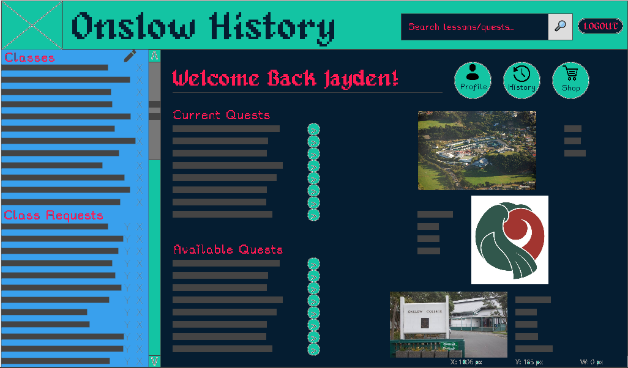

1. Circle/highlight the words that come to mind when you look at the **colour** scheme.

|  |  |  |  |  |  |
| --- | --- | --- | --- | --- | --- |
| Professional | Warm | Childish | Simple | Shambolic | Relaxed |
| Overbearing | Casual | Engaging | Clever | Serious | Cold |
| Sloppy | Trustworthy | Playful | Interesting | Easy | Arrogant |
| Inclusive | Sleek | Detailed | Confident | Chilled | Clinical |
| Authoritative | Exciting | Open | Laid back | Fun | Amateur |
| Supportive | Stuffy | Silly | Helpful | Enthusiastic | Bossy |

1. Circle/highlight the words that come to mind when you look at the **font** scheme.

|  |  |  |  |  |  |
| --- | --- | --- | --- | --- | --- |
| Professional | Warm | Childish | Simple | Shambolic | Relaxed |
| Overbearing | Casual | Engaging | Clever | Serious | Cold |
| Sloppy | Trustworthy | Playful | Interesting | Easy | Arrogant |
| Inclusive | Sleek | Detailed | Confident | Chilled | Clinical |
| Authoritative | Exciting | Open | Laid back | Fun | Amateur |
| Supportive | Stuffy | Silly | Helpful | Enthusiastic | Bossy |

1. Are there any other words that you associate with this mock-up?

|  |
| --- |
| Calm, inviting |

1. What do you think about the choice of:

|  |  |
| --- | --- |
| Background colour | good dark colour choice |
| Text colour(s) |  |
| Text-on-background combination | Text colour gives the website some extra pop |
| Accent colour(s) |  |

1. Circle/highlight any statements you find applicable:

|  |  |  |
| --- | --- | --- |
| The **colours** in the mock-up make text hard to read | The **colours** in the mock-up make it hard to see where I need to interact (click, tap, type, etc.) | The **colours** in the mock-up make it hard to distinguish different sections |
| The **fonts** (including typeface, size, spacing, etc.) in the mock-up make text hard to read | The **fonts** (including typeface, size, spacing, etc.) in the mock-up make it hard to see where I need to interact (click, tap, type, etc.) | The **fonts** (including typeface, size, spacing, etc.) in the mock-up make it hard to distinguish different sections |
| I have not found anything in the mock-up that makes text hard to read | I have not found anything in the mock-up that makes it hard to see where I need to interact | I have not found anything in the mock-up that makes it hard to distinguish different sections |

1. Do you have any other feedback?

|  |
| --- |
| [Type here] |

1. What are the pros of this mock-up?

|  |
| --- |
| [Type here] |

1. What do you think could be improved about this mock-up?

|  |
| --- |
| [Type here] |

# Review

1. Overall, which mock-up did you prefer?

|  |
| --- |
| I preferred mock-up number 2 overall |

1. Why did you prefer that mock-up over the others?

|  |
| --- |
| The colour was the best |

1. What suggestions do you have that I could do to **improve** your preferred mock-up?

|  |
| --- |
| I would say change the font |